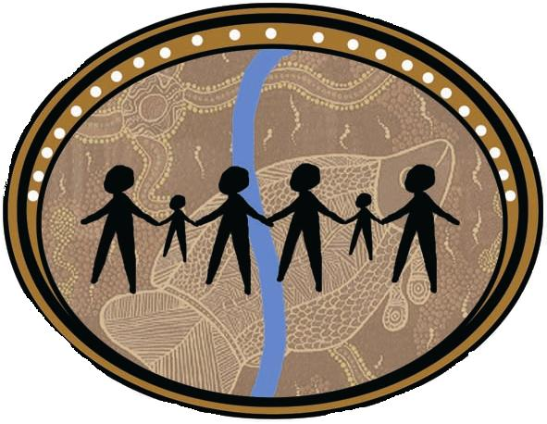 | Albury Wodonga Aboriginal Health Service Inc  ABN: 84286953178  Phone: (02) 6040 1200 Fax: (02) 6040 1222  Toll Free: 1800 421 640  644 Daniel Street Glenroy 2640  (PO Box 3040, Albury, NSW, 2640)  Level 4 111- 113 Hume Street, Wodonga, VIC, 3690  89-90 Rowan Street, Wangaratta, VIC, 3677

POSITION DESCRIPTION

Position Title : Mental Health Clinician

Reports to: Program Manager

Term of Employment: Full Time - funded position

Award : Aboriginal Community Controlled Health Services Award 2010

Salary: As per contract

Position Approval  Updated:  Last updated: | Approved: David Noonan  Date: 10/11/2021

ORGANISATION
Albury Wodonga Aboriginal Health Service Inc. (AWAHS) is an Aboriginal Community Controlled Health Organisation. AWAHS provides first class Primary Health Care Services to the Aboriginal community who reside in Albury / Wodonga and surrounding areas. As a Bulk Billing Health Service there is no charge to our clients for the medical services provided.

VISION STATEMENT
To provide comprehensive quality health and family services based on respect for Aboriginal Culture.

POSITION PURPOSE
- The Mental Health Clinician will be directly responsible for promoting a client focused approach to engaging with family, carers and clients impacted by mental health challenges

- The Mental Health Clinician will provide a Case Management approach to client support.

- The Mental Health Clinician will provide clinical services to clients requiring medical support for their mental health diagnosis

- The Mental Health Clinician will promote the social and emotional wellbeing of Aboriginal people by ensuring that programs and services are delivered from a culturally sensitive holistic perspective, within the principles and goals of Primary Health Care.

- The Mental Health Clinician will work towards increasing access to Mental Health Services within the local Aboriginal community.

- The Mental Health Clinician will encourage the local Aboriginal community to take responsibility for their own health, the health of their families and the health of the broader Aboriginal Community

- The Mental Health Clinician will build productive and meaningful relationships with mainstream health providers who deliver Mental Health Programs and Services.

RELATIONSHIPS
Supervision

The position reports directly to the Programs Manager of AWAHS

Internal
The Mental Health Clinician will work collaboratively with all other team members of AWAHS.

External
The Mental Health Clinician will be expected to liaise with key stakeholders who are involved with Mental Health issues affecting our local Aboriginal community. The liaison will also include other local Aboriginal Organisations.

DUTIES OF THE POSITION

Clinical Service Provision
- Assess the mental health support needs and provide support and case management services to Aboriginal persons and their families.
- Provide Mental Health medical support to Aboriginal persons and their families
- Provide assertive outreach support to people with complex care needs.
- Work in partnership with clients in the provision of Recovery Focused Interventions and the development of goals identified in an agreed plan.
- Ensure access to mainstream and specialist services for Aboriginal people.
- Work with service providers from other agencies, to add to the flexible service response needed to work with the Aboriginal people.
- Participate in the planning, implementation, and provision of group options.
- Provide discipline-specific input to the team’s work and to other programs within the Service.
- Liaise with a range of clinical, community groups and agencies with a view to improving the provision and co-ordination of a broad range of services to the target group.
- Provide detailed Mental State Examination, Risk Assessment of clients.
- To provide consultation to health professionals regarding mental health assessments and other relevant assessments.
- Triage/acute presentation support mentall health screening and assessment.
- First aid assistance with emergency procedures
- Working closely with the clinic doctors/nurses around the assessment, preparation of management plans and health checks, involvement in disease specific clinics, referrals to allied health services, referrals to health programs, & regular review of recall register.
- Organising & referring clients for home medication reviews & supporting clients who attend the clinic for mental health medication management.
- Case conferences & care planning.

Community Development/Health Promotion
- Participate in the development of community work projects and programs designed to enhance the community’s ability to respond to the needs of Aboriginal people.
- Liaise with mainstream and specialist service providers to ensure effective service delivery and continuity of care for the Program's clients.
- Provide community education, awareness and prevention programs in social and emotional health.
- Work with the community to develop and implement a range of activities to promote acceptance of people with mental disorders and/or mental health problems by reducing stigma in the community.
- Work collaboratively with other service providers to develop and implement cultural understanding within health staff’s work practices.

Administrative
- Maintain accurate client and program records and statistics as required.
- Actively uphold the AWAHS philosophy, policies and procedures.
- Participate in the ongoing development and implementation of policies which are sensitive to the identified health needs and concerns of Aboriginal people/communities and which reflect the principles of social justice and equity, by consultation, participation and advocacy in appropriate forums.
- Maintain confidentiality.
- Contribute to the development and maintenance of a supportive environment within the team.
- Participate in the evaluation of the Program's services and group activities.
- Work in accordance with the EEO, OH&S, Code of Conduct and safe working practices, policies and procedures of the Albury Wodonga Aboriginal Health Service.

Professional
- Accept personal responsibility and be accountable for professional practice.
- Participate in performance appraisal and supervision processes.
- Maintain professional skills and knowledge via appropriate staff development activities.
- Demonstrate excellent communication skills in recording and reporting information to the multidisciplinary team.
- Participate in quality improvement activities.
- Work as part of a team and actively participate in staff meetings.
- Participate in research activities including the compilation of daily and monthly statistics on the services provided as required.
- Maintain ongoing education, training & nursing competencies & attends conferences & seminars related to relevant areas of clinical practice & that address specific Aboriginal Health Needs.
- Maintain skill in CPR & Emergencies on an annual basis.
- Maintains compliance with all statutory & regulatory obligations, including Nursing Registration, working within Practice Nurses scope of practice, infection control & sterilisation requirements, spills management, hazardous materials & safe handling/disposal of medical waste, records management, and WHS & Accreditation requirements.
- Maintain and provide records & clinical statistics in preparation for the lodgement of the Annual Service Activity Report & other data collection requirements.
- Planning and management of care in conjunction with the outreach nurse and support worker

Mandatory Requirements
- Comply with the Mental Health Act.
- Comply with the NSW Department of Community Services mandatory child protection reporting regulations.

ORGANISATION CHART
Refer to attached AWAHS Organisational Chart.

SELECTION CRITERIA

- Qualifications in the field of health/social or behavioural sciences or other relevant to the role- preferred
- Current registration as a Registered Nurse (Division 1)
- Nursing experience within primary health care.
- Extensive experience within a similar role
- Demonstrated knowledge and understanding of Aboriginal and Torres Strait Islander cultures and have established links with the local community.
- Excellent communication and computer skills –Microsoft Office
- Proven experience in program development and implementation.
- Demonstrated knowledge of current health issues relevant to Aboriginal & Torres Strait Islander communities.
- Current Drivers Licence

Desirable
- Understanding of the relevant legislation including the Mental Health Act.
- Knowledge of enhanced primary health care.

Employment Prerequisites
- Current and clear Criminal Record Check
- Current and clear Working with Children Check
- Completed and appropriate for employment Health Declaration Form
- This is a designated Aboriginal/Torres Strait Islander Position. Proof of Aboriginality is a legitimate requirement. Exemption is claimed under Section 14 of the Anti-discrimination Act.
- Current registration with the Australian Health Practitioners Regulation Agency

Declaration
I acknowledge that I have read the Position Description and understood its contents and agree to work in accordance with the requirements of the position. I also understand and accept that I must comply with the organisation’s policies and procedures including Confidentiality and Code of Ethics during and beyond my employment with Albury Wodonga Aboriginal Health Service Inc.

…………………………………………  Name:  …………………………………  Date: | …………………………………………  Signature:

